Data Structure and Algorithm

Laboratory Activity No. 5

Implementation of Arrays

|  |  |
| --- | --- |
| *Submitted by:* | *Instructor:* |
| Caasi, Karl Benedict D. | Engr. Maria Rizette H. Sayo |

August 23, 2025

# Objectives

Introduction

Array, in general, refers to an orderly arrangement of data elements. Array is a type of data structure that stores data elements in adjacent locations. Array is considered as linear data structure that stores elements of same data types. Hence, it is also called as a linear homogenous data structure.

This laboratory activity aims to implement the principles and techniques in:

* Writing algorithms using Array data structure
* Writing a python program that can implement Array data structure

# Methods

* Write a Python program to create an array of 10 integers and display the array items. Access individual elements through indexes and compute for the sum.
* Write a Python program to append a new item to the end of the array. Original array: numbers = [1, 2, 3, 4, 5, 6, 7, 8, 9, 10]
* Write a Python program to insert a new item before the second element in an existing array. Original array: numbers = [1, 2, 3, 4, 5, 6, 7, 8, 9, 10]
* Write a Python program to reverse the order of the items in the array. Original array: numbers = [5, 4, 3, 2, 1]
* Write a Python program to get the length of the array. Original array: numbers = [5, 4, 3, 2, 1]

# Results

Present the visualized procedures done. Also present the results with corresponding data visualizations such as graphs, charts, tables, or image . Please provide insights, commentaries, or explanations regarding the data. If an explanation requires the support of literature such as academic journals, books, magazines, reports, or web articles please cite and reference them using the IEEE format.

Please take note of the styles on the style ribbon as these would serve as the style format of this laboratory report. The body style is Times New Roman size 12, line spacing: 1.5. Body text should be in Justified alignment, while captions should be center-aligned. Images should be readable and include captions. Please refer to the sample below:

Figure 1 Screenshot of program

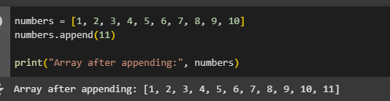 The program creates a list of 10 numbers, prints the full list, shows the first and fifth numbers using their positions, and then calculates and displays the total sum of all the numbers.

Figure 2 Screenshot of program  
  
  
The program adds the number 11 to the end of the list and then prints the updated list.  
  
  
  
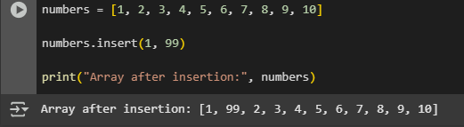

Figure 3 Screenshot of program  
  
  
The program inserts the number 99 at the second position (index 1) of the list and then displays the updated list.  
   
  
Figure 4 Screenshot of program

The program begins with a list in reverse order, [5, 4, 3, 2, 1], uses the reverse () method to flip it, and then prints the updated list as [1, 2, 3, 4, 5].

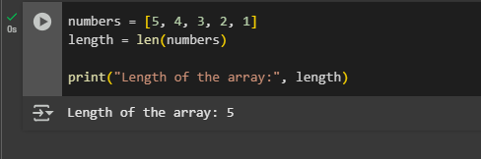

Figure 5 Screenshot of program  
The program calculates how many elements are in the list [5, 4, 3, 2, 1] using the len() function and prints the result as 5.  
  
  
Conclusion  
This set of Python programs demonstrates basic list operations, including creating a list, accessing elements, summing values, appending and inserting new items, reversing the list, and finding its length. These examples help illustrate how fundamental list functions work in Python, making it easier for beginners to understand core programming concepts through simple and practical use cases.  
  
REFERENCE  
• Python documentation –Lists: https://docs.python.org/3/tutorial/datastructures.html#more-on-lists

• W3Schools Python List Tutorial: https://www.w3schools.com/python/python_lists.asp

• Geeks for Geeks – Python List Methods: https://www.geeksforgeeks.org/python-list/